Proposal
Change the text in the graduate catalog to align with the undergraduate catalog which is more specific (ex. excusable absences).

Current Graduate Catalog:
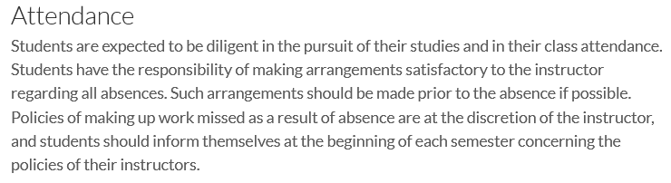

Current Undergraduate Catalog:
