The UA currently accepts three measures of English language proficiency for the admission, enrollment, and assistantship qualifications for non-native English speakers: iBT TOEFL (internet- based Test of English as a Foreign Language), IELTS (International English Language Testing System), and the PTE-A (Pearson Test of English-Academic). <https://international-admissions.uark.edu/graduate-studies/english-proficiency.php>

**The UA English as a Second Language Committee proposes approval to accept:**

1. The **iTEP Academic** **-Plus** and the **C1 Advanced** examinations to meet the UA English language proficiency requirements for non-native English speakers, for admission and placement purposes.
2. The **Duolingo English Test (DET)** as a supplemental assessment for use on a case-by-case basis with the understanding that additional assessments would be required upon the student’s arrival to campus.
3. The proposed test score equivalencies for admission, enrollment, and assistantship qualifications

**iTEP Academic -Plus: International Test of English Proficiency**

<https://www.itepexam.com/products/itepacademic/>

***Rationale:***

* First administered in 2008
* Delivered over the internet and administered at 600+ test centers in 61 countries.
* iTEP Academic is administered in 90 minutes. Results are available within five business days. 300+ universities accept the iTEP for admissions.
* The exam has five sections—reading, listening, grammar, writing, and speaking. Test-takers write and speak during the test. Their samples are scored by ESL-qualified graders
* The test determines an overall proficiency level from 0 (beginner) to 6 (mastery), as well as individual proficiency levels from 0 to 6 for each of the skills and sub-skills tested. The overall scores combine the results of the skill sections and are expressed to one decimal point (from 0.0 to 6.0).
* The grammar, listening, and reading sections are scored automatically by iTEP software.
* The writing and speaking sections are evaluated by native English-speaking, English as a Second Language trained professionals, according to a standardized scoring rubric.
* The official score report presents an examinee’s scoring information, displaying an examinee’s strengths and weaknesses in each of the skills and sub-skills tested.

Cost: $129.00

The University of Arkansas would become an authorized iTEP testing center, the only one in the state.

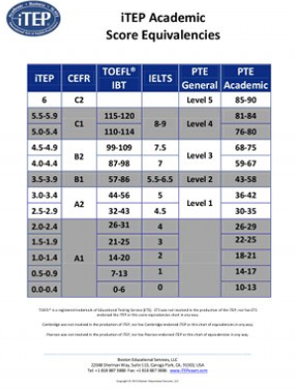

**C1 Advanced (Cambridge Assessment English)**

[**https://www.cambridgeenglish.org/exams-and-tests/advanced/**](https://www.cambridgeenglish.org/exams-and-tests/advanced/)

***Rationale:***

* Cambridge Assessment English(CAE) is part of the University of Cambridge, UK.
* CAE also administers the IELTS.
* CAE administers both the Cambridge International Advanced Subsidiary Levels (AS Levels) and Cambridge International Advanced Levels (A Levels) – which we accept for UA undergraduate admission consideration.
* C1 Advanced was originally introduced in 1991 and can be taken as either a paper-based or computer-based exam at 2800+ test centers in over 130 countries.
* The exam is administered in four hours. Results are released on-line within 2- 3 weeks for computer based and 4 - 6 weeks for paper-based. It is accepted globally by over 6,000 institutions.
* C1 Advanced has five sections: reading, use of English, writing, listening, and speaking. Reading and Use of English, Writing and Listening papers are taken on the same day. The Speaking paper may be taken a few days before or after the exam. Total 4 hours for all five sections.
* Scoring is based on the Common European Framework of Reference for Languages (CEFR). The CEFR is an international standard for determining ability within a language. It was established by the Council of Europe and aims to validate language ability. The six levels within the CEFR are A1, A2, B1, B2, C1 and C2.

Cost: $200.00

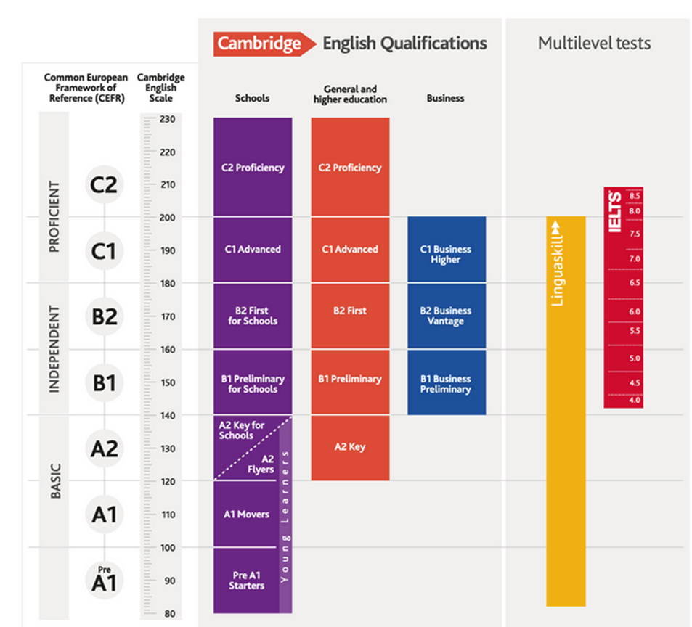

**The EASL Committee recommends the following score requirements** for 1) admission consideration, 2) writing score requirements for enrollment, and 3) speaking scores required to hold a TA that requires direct contact with students in a teaching or tutorial role, in a traditional classroom setting or via distance education.

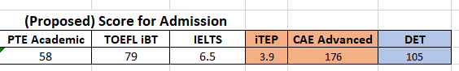



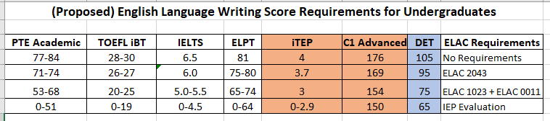

ELAC 0011 Writing Workshop: Grammar through Editing

ELAC 1023 Academic Writing Across Disciplines

ELAC 2043 Seminar in U.S. Culture, Communication, and Institutions

ELAC 5033 Research Writing for Social Sciences and Education

ELAC 5043 Research Writing in the STEM Fields

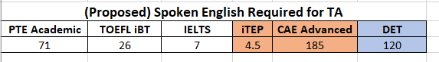

**Duolingo English Test (DET)**

We also propose the Duolingo English Test (DET) as a supplemental assessment for use on a case-by-case basis with the understanding that additional assessments would be required upon the student’s arrival to campus. <https://englishtest.duolingo.com/>

Examples of when the DET would be used:

1. For applicants from countries that do not administer our approved English language exams (e.g. TOEFL, IELTS) due to political (e.g. Syria, Cuba) reasons.
2. For applicants from countries that temporarily suspend administration of English language exams (e.g. TOEFL, IELTS) due to health concerns (e.g. China, Macau, Hong Kong) or catastrophic events.
3. For applicants whose TOEFL/IELTS/etc have recently expired and they are currently living, working, or studying in a country where English is the native language.
4. For applicants who have a U.S. masters’ degree but have not lived/worked/studied in a

country where English is the native language within five years after graduation.

1. For applicants recruited by UA faculty without sufficient time to register for/and complete one of our approved English language assessment examinations.

*Rationale* for use as a supplemental measure:

* is on-line and can be taken anywhere, any time with reliable internet access and a webcam-enabled computer. It is an adaptive test taking 55 minutes to complete.
* Developed in 2014. Results are available within 48 hours. 500+ universities worldwide accept the DET for admissions. University of Arizona, Arizona State, University of Alabama, Columbia University, Bowdoin, Colby and Middlebury Colleges are examples of U.S. institutions who accept the DET.
* The Duolingo English Test is designed to assess real-world language ability, by measuring reading, writing, speaking, and listening skills. Each test taker's proficiency is reported as a holistic score on a scale from 10 – 160.

Cost: $49.00

